Section 1: Case Summary

Scenario Title: | Pediatric Traumatic Brain Injury
Keywords: | Traumatic brain injury, Peds, Trauma
Brief Description of Case: | An 18-month-old presents to the ED at a community hospital with a head injury following an unwitnessed fall from significant height with initial loss of consciousness. He presents irritable but stable, and subsequently develops signs of increased ICP progressing to herniation (secondary to an epidural hematoma)

Goals and Objectives
Educational Goal: | Practice management of pediatric traumatic brain injury
Objectives:  (Medical and CRM) | 1. Lead team through care of critically ill infant including assigning roles, using closed-loop communication and using a shared mental model  2. Perform ATLS-based primary and secondary survey of a pediatric patient  3. Recognize signs of traumatic brain injury in a trauma patient  4. Manage TBI and increased ICP using evidence-based practices  5. Re-assess patient with physiologic parameters change  6. Consider non-accidental injury in pediatric trauma patients
EPAs Assessed: | TTD EPA #1 – recognizing the unstable/critically ill patient and subsequently mobilizing care from healthcare team to initiate basic life support interventions  Foundations EPA #1 - initiating resuscitation of critically ill patients  Core EPA #2 – resuscitating and coordinating care for a critically injured patient Core EPA #3 – providing airway management and ventilation

Learners, Setting and Personnel
Target Learners: | ☒ Junior Learners |  | ☒ Senior Learners |  |  | ☐ Staff
 | ☒ Physicians | ☐ Nurses |  | ☐ RTs | ☐ Inter-professional
 | ☐ Other Learners:
Location: | ☒ Sim Lab |  | ☐ In Situ |  |  | ☐ Other:
Recommended Number of Facilitators: | Instructors: 1
 | Sim Actors: 1
 | Sim Techs: 1

Scenario Development
Date of Development: | September 2020
Scenario Developer(s): | Dr. Diana De Santis, Dr. Jennifer Klowak, Dr. Quang Ngo
Affiliations/Institutions(s): | McMaster University
Contact E-mail: | Diana.desantis@medportal.ca qngo@mcmaster.ca jklow091@uottawa.ca
Last Revision Date:
Revised By:
Version Number:

Section 2A: Initial Patient Information

- Patient Chart
Patient Name: Sam |  |  |  | Age: 18 months | Gender: M | Weight: 12.5 kg
Presenting complaint: Head injury
Temp: 37° C | HR: 145 | BP: 90/50 |  | RR: 35 | O₂Sat: 98% | FiO₂: room air
Cap glucose: 4 |  |  |  | GCS: 11 (E3 V3 M5)
Triage note: Brought to ED by Mom after a fall off of playground in backyard (approximately 6 ft off ground). Mom heard a bang and then saw him on the ground. He had LOC x1 minute then woke up crying inconsolably. Mom did not see the fall as she was watching her other child inside the house. Vomited x1 en route to ED. Mom is currently out of the department giving her other child to grandparents in the parkade.
Allergies: None
Past Medical History: Previously healthy |  |  | Current Medications: None

Section 2B: Extra Patient Information

A. Further History
N/A
B. Physical Exam
Cardio: Tachycardic, capillary refill 2 seconds | Neuro: Pupils 4 mm and reactive. Quiet, moaning, cries with painful stimuli (i.e. IV insertion)
Resp: Clear breath sounds bilaterally | Head & Neck: Boggy hematoma left parietal scalp
Abdo: Normal | MSK/skin: Bruise on abdomen
Other: Normal

Section 3: Technical Requirements/Room Vision

A. Patient
☒ Mannequin (Toddler)
☐ Standardized Patient
☐ Task Trainer
☐ Hybrid
B. Special Equipment Required
Gloves, PPE, stethoscope
IV lines, IO set-up, IV push medications
Nasal prongs, venturi mask, non-rebreather mask, bag valve mask, laryngoscope, ET tubes
Cervical spine collar

C. Required Medications
Normal saline
Mannitol, hypertonic saline
Medications for RSI and sedation

D. Moulage
Boggy swelling to left parietal scalp

E. Monitors at Case Onset
☐ Patient on monitor with vitals displayed
☒ Patient not yet on monitor
F. Patient Reactions and Exam
Pupils 4 mm and reactive
Crying with painful stimulus (i.e. IV insertion)

Section 4: Sim Actor and Standardized Patients

Sim Actor and Standardized Patient Roles and Scripts
Role | Description of role, expected behavior, and key moments to intervene/prompt learners. Include any script required (including conveying patient information if patient is unable)
ED RN | Skillful andhelpful. Reviews patient notes from triage, provides support with monitor application, IV start, medication administration, providing lab results.  Key moments to prompt if not recognized by leader: recognition of head injury, deterioration in patient’s GCS status, development of signs of increased ICP
Respiratory Therapist | Assists with airway support if requested

Section 5: Scenario Progression

Scenario States, Modifiers and Triggers
Patient State/Vitals | Patient Status | Learner Actions, Modifiers & Triggers to Move to Next State |  | Facilitator Notes
1. Baseline State  Rhythm: Sinus tach  HR: 145  BP: 90/50  RR: 35  O₂SAT: 98 %  T: 37ºC  GCS: 11  AVPU: Verbal | Quiet, moaning, cries with painful stimulus (IV insertion) | Expected Learner Actions  Place monitors  Primary survey (ABCDE) including GCS and pupils  Identifies skull injury and suspected TBI  Immobilization of cervical spine  Obtain 2 large bore PIVs  Send trauma bloodwork  Checks cap glucose | Modifiers  - Labs to be provided if requested  Triggers  After 4 minutes or all actions complete → 2. Incr ICP (gradual progression toward state 2 vital signs) | As noted above, parent no longer present in ED therefore further patient information (beyond triage note) not available.
2. Increased ICP  Rhythm: Sinus brady  HR: 55  BP: 140/100  RR: 10 (irregular)  O₂SAT: 93%  GCS: 5 (E1 V1 M3)  AVPU: Pain | Patient stops crying and GCS declines.  Develops signs of Cushing’s triad.  Pupils:  right 4 mm sluggish  left 8 mm unreactive | Expected Learner Actions  Re-examine patient given clinical change  Identify signs of increased ICP  Elevated head of bed  Administer mannitol or hypertonic saline  Assist respirations with BVM  Prepare for intubation  Consider seizure prophylaxis  Call for clinical help (extra hands, neurosurgery, PICU)  Ask for help finding mom | Modifiers  - If no BVM initiated saturations drop to ~ 80%  - If requests PICU back-up, not immediately available  - If requests STAT CT, RN to prompt that patient needs to be stabilized  Triggers  Decision to intubate → 3. Intubation | No neurosurgical or ICU back-up available in this centre
3. Intubation  Rhythm: Sinus  HR: 60  BP: 130/90  RR: 12 (irregular)  O₂SAT: 93%  GCS: 5 (E1 V1 M3) | Unchanged | Expected Learner Actions  Verbalize airway plan including ventilation strategy  Use Broselow tape to select appropriate size tube and depth  Maintain inline stabilization  Perform RSI (may consider neuroprotective adjuncts)  Confirms tube placement | Modifiers  - If mannitol or hypertonic saline initiated, left pupil begins to improve  Triggers  Intubation complete → 4. Disposition
4. Disposition  Rhythm: Sinus  HR: 100  BP: 110/90  RR: per vent  O₂SAT: 98%  GCS: 2T  AVPU: Unresponsive | Patient paralyzed.  Improvement in vital signs.  Pupils now 4 mm and reactive. | Expected Learner Actions  Choose appropriate sedation  Re-assess ABCs +/- secondary survey  Order neuro and cervical spine imaging  Verbalize targets for neuroprotective measures (T, BG, Na, pCO2)  Arrange for transfer to tertiary care centre | Modifiers  -Prompt to present the case for transport when PICU calls back (at the end of state 4)  Triggers  Arrange transport → END CASE

Appendix A: Laboratory Results

CBC  WBC 8  Hgb 130  Plt 200  Lytes  Na 140  K 4.4  Cl 100  Urea 5  Cr 30  Glucose 4  Extended Lytes  Ca 2.2  Mg 0.9  PO₄ 1.5  VBG (start of case)  pH 7.3  pCO₂ 48  pO₂ 80  HCO₃ 22  Lactate 1 | Cardiac/Coags  INR 1  aPTT 30  Biliary  AST 20  ALT 20  GGT 15  Bili 2  Lipase 10  Tox  EtOH neg  ASA neg  Tylenol neg

Appendix B: ECGs, X-rays, Ultrasounds and Pictures

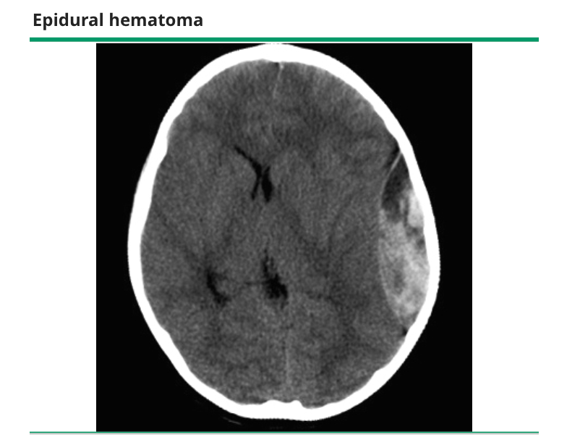
From: Up-to-Date, Severe traumatic brain injury in children: Initial evaluation and management

Appendix C: Facilitator Cheat Sheet & Debriefing Tips

Questions for Discussion/Debrief

- What are important signs of traumatic brain injury?
- What are signs of impending cerebral herniation?
- What is the current evidence re: hyperventilation in the setting of traumatic brain injury? (What are your targets?)
- What are the targets for neuroprotective measures?
- What RSI medications would you consider in cases of TBI and increased ICP?
- How would you approach the concern of possible NAI given the report of unwitnessed injury?

References

1. Kochanek PM, Tasker RC, Carney N, et al. Guidelines for the Management of Pediatric Severe Traumatic Brain Injury, Third Edition: Update of the Brain Trauma Foundation Guidelines, Executive Summary. Pediatr Crit Care Med 2019; 20:280.
2. Stone, K. and Reid. R. Institute for Simulation and Interprofessional Studies at the University of Washington Resource Guide: Pediatric Emergency Medicine Simulation Traumatic Brain Injury. February 2015.
3. Farrell, A. Management of the pediatric patient with acute head trauma. Canadian Pediatric Society Acute Care Committee. Paediatric Child Health 2013; 18(5):253-8
4. Valvilala, M.S. and Tasker, R.C. Severe traumatic brain injury in children: Initial evaluation and management. UpToDate. August 2019.

